# Docker for Web Developers–Whole Practice Assignment

**Problem:**

"Create your account on DigitalOcean and create a droplet on the Digital Ocean platform with any Ubuntu 14.04.

Install VNC viewer & GIT on the ubuntu server. Signup or login to the docker & bitbucket. Search & download 2048 image from the docker repository. Run the image in bash shell usingthe start_vnc.sh script & verify if the image is running. Remove the image with the help of container_id.Login to the VM with the help of SSH. Run the docker image on port number 5902 with bash shell in the backend. List the processes running inside the docker. Run a new instance of the game. Save the state of the game. Perform new tasks in the game & then restore the game. Upload the same image to the docker repository & verify the image on the docker portal. Pull an Ubuntu image from the docker repository. Verify its image ID & Tag the same image with another reference name. Check the history of the docker image you are using. List the detailed event of the docker image. Run a docker image on the linux terminal. List the logs for the image. Stop the docker image using the ID. Create a git clone, Built it & verify. Download the themorgagemeter archive file from the git. Run the themortgagemeter & verify it by entering the IP address on the web browser. Host the 'themortgagemeter' image directly to the host & map virtual server port 80 to the container's port 80. Give a name to the existing docker image & Create another docker image by linking it to existing docker image. Download & install 'docker-compose' & verify it's version. Create a YAML configurefile with for the previously created linked docker images. Publish the yaml configuration file. Search for docker compose example file on docker repository & clone it on the system. Also verify if the SQLite DB is mounted for the first docker image.

**Solution:**

Create your account on DigitalOcean and create a droplet on the Digital Ocean platform with any Ubuntu.

Go to DigitalOcean.com:

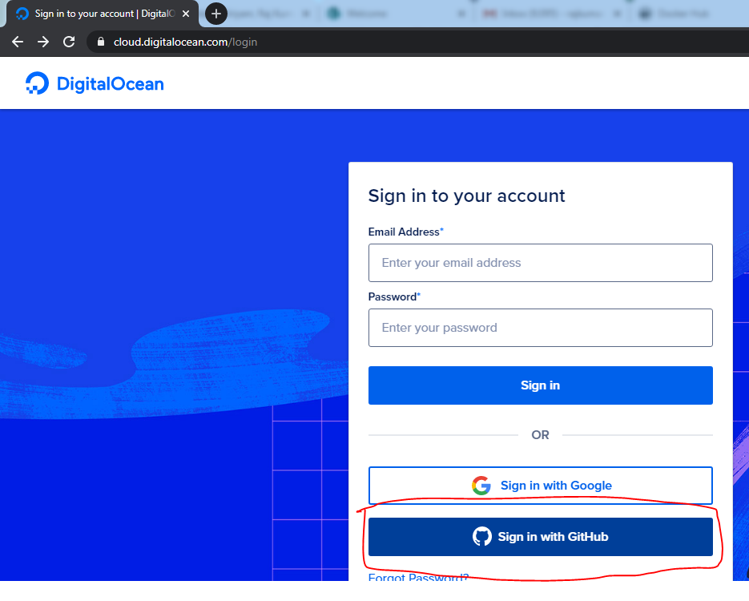

Logged in with GitHub account:

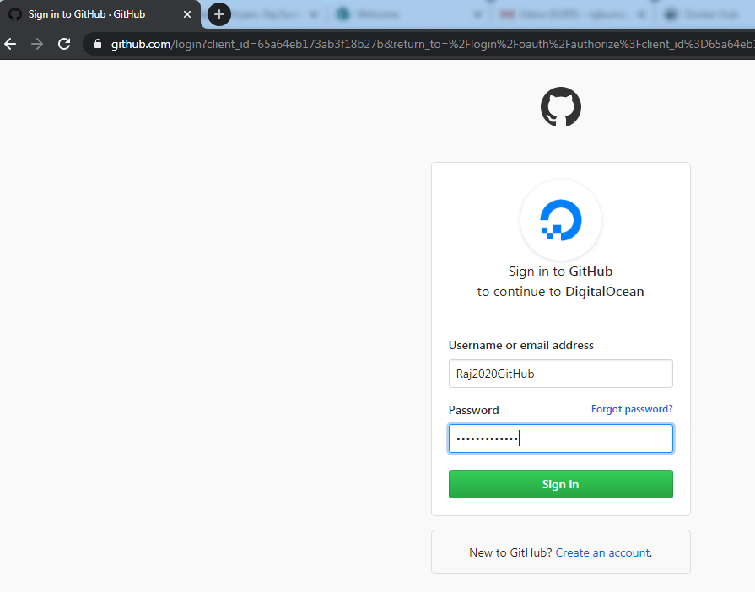

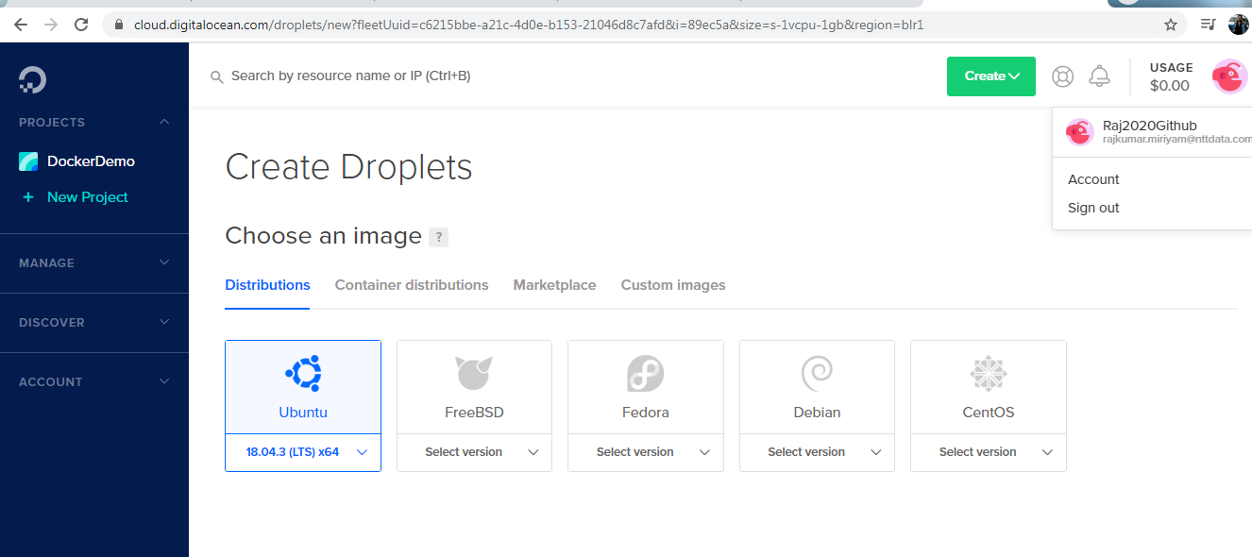

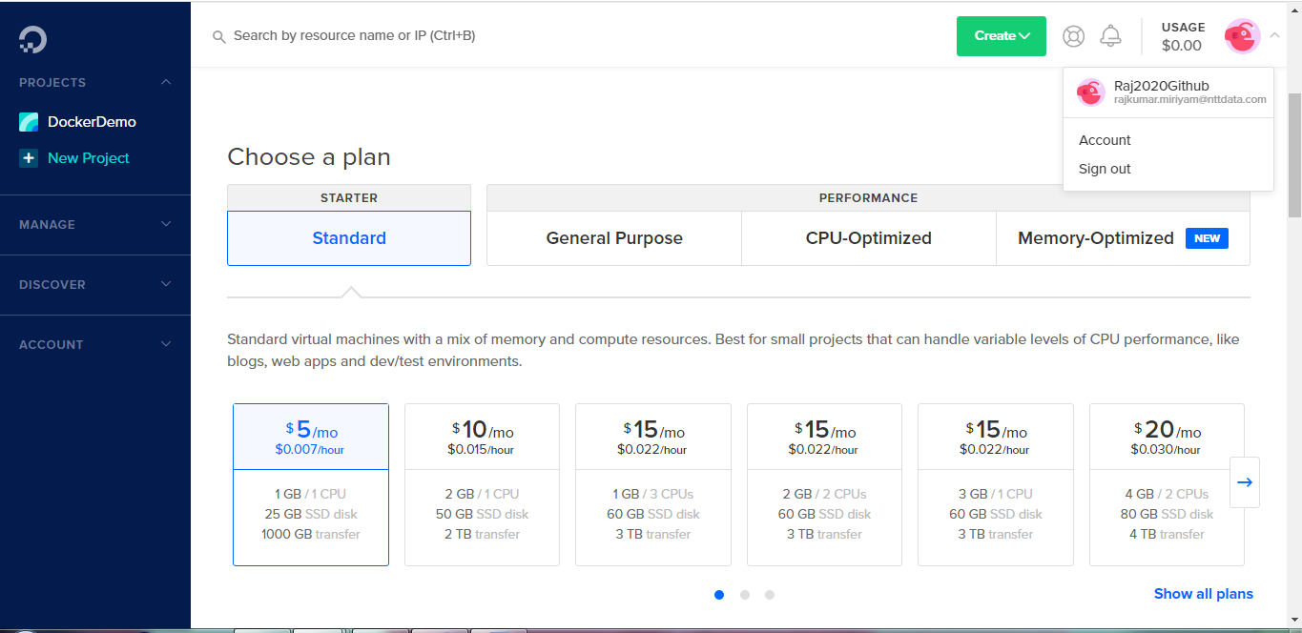

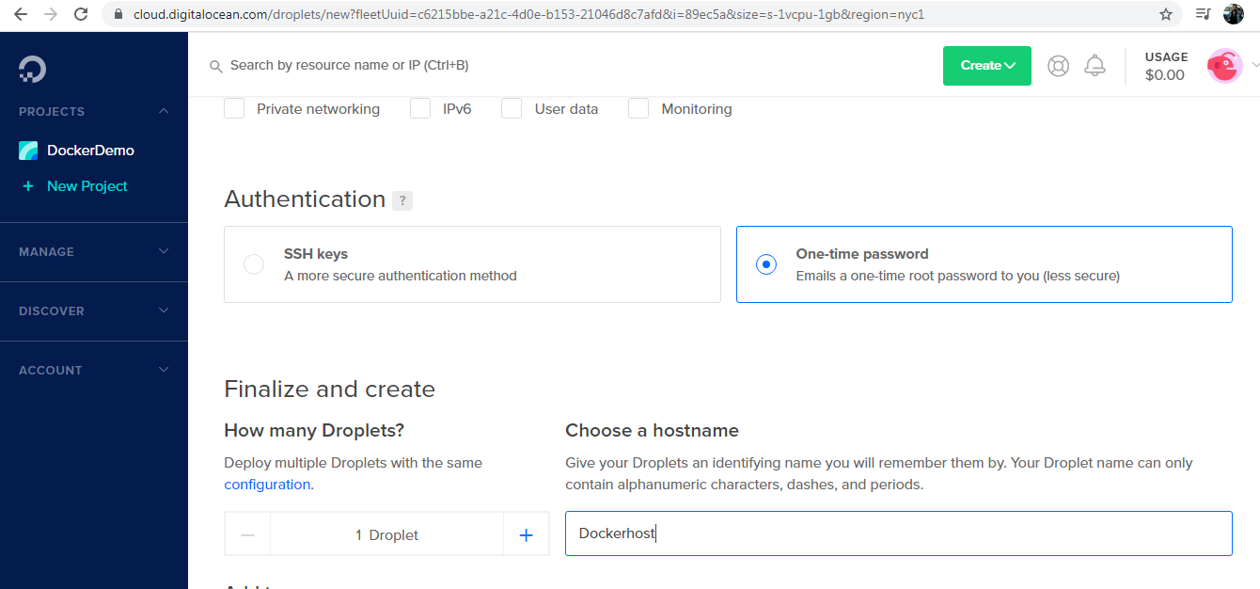

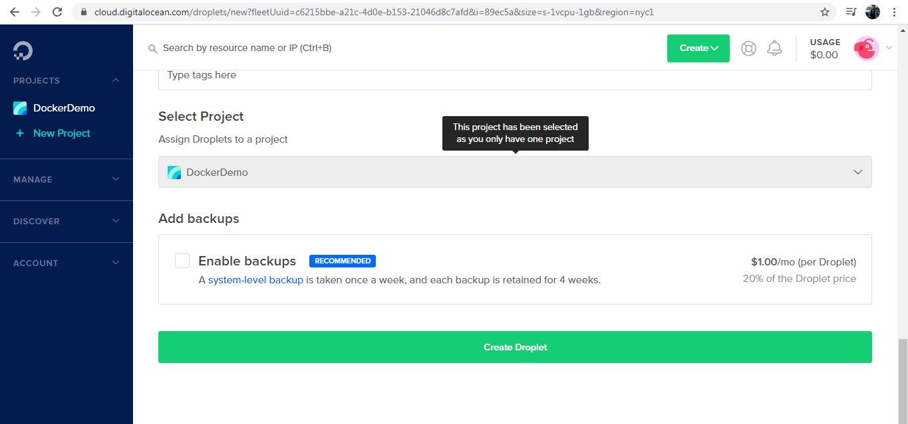

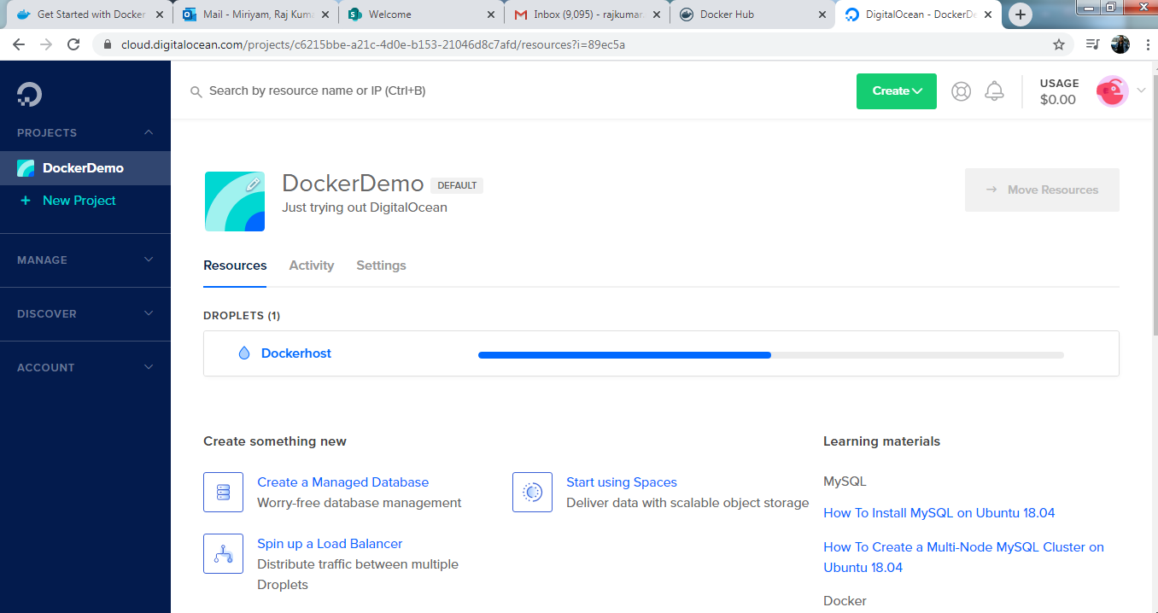

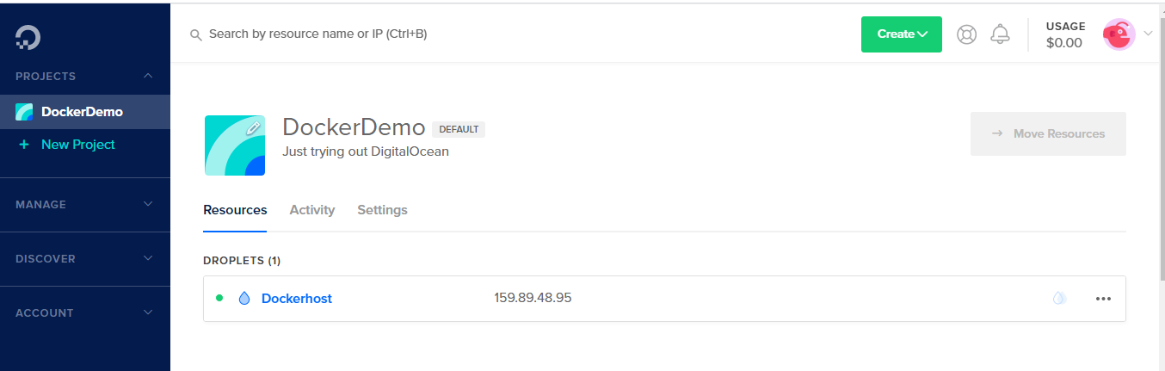

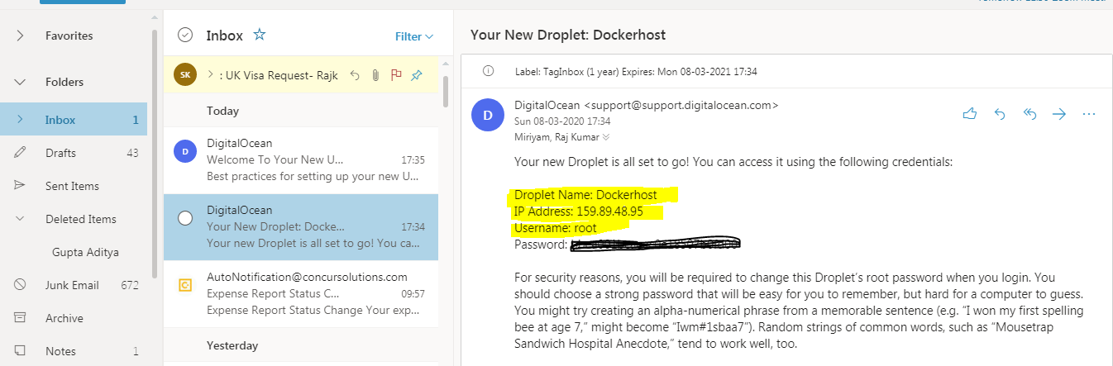

**install Docker:**

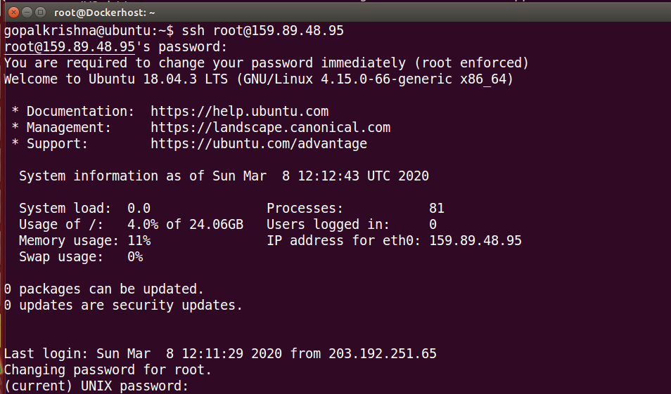

**Docker Pull ubuntu:**

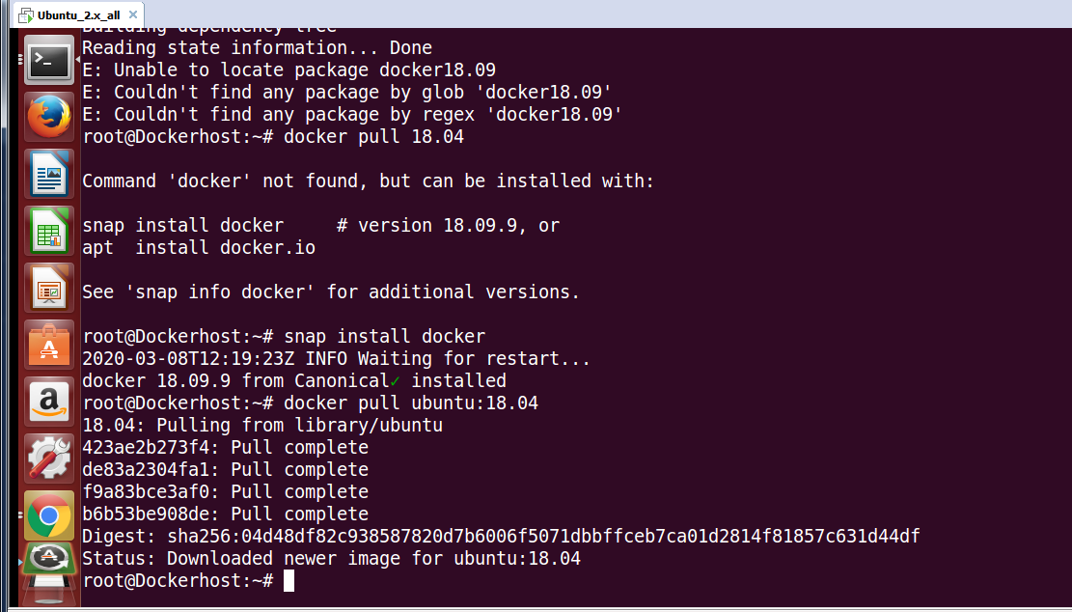

**Run Docker Container:**

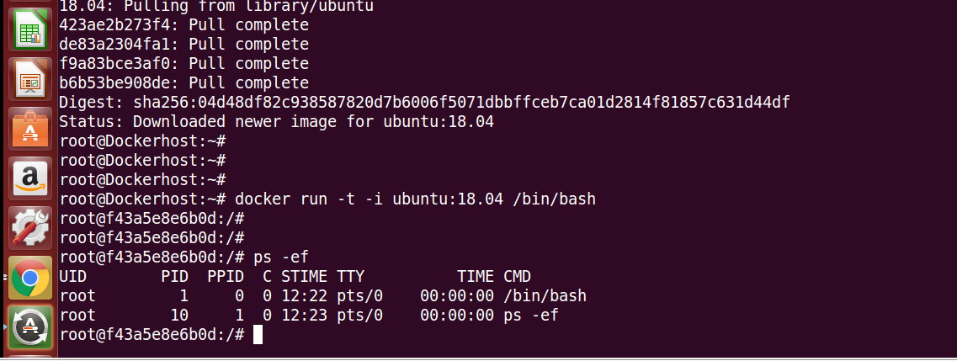

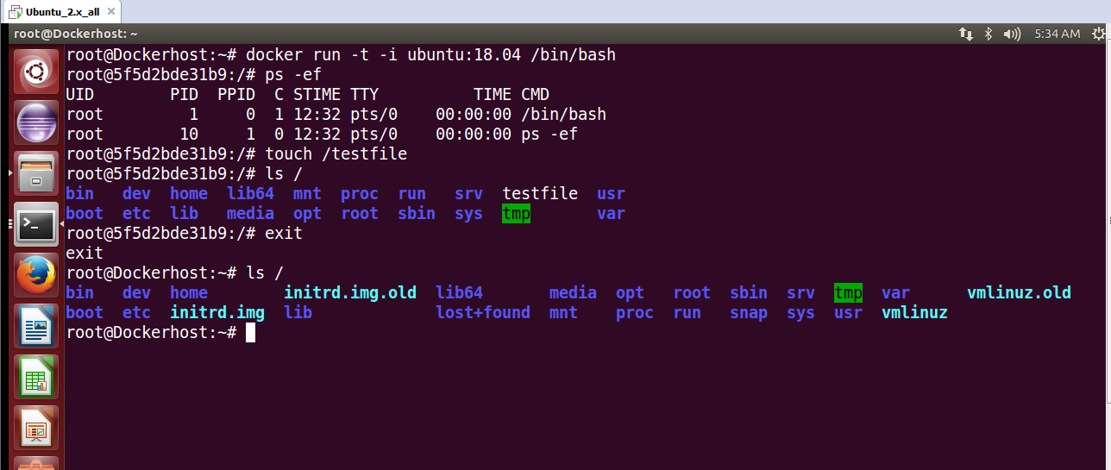

**Install VNC Viewer on the ubuntu server:**

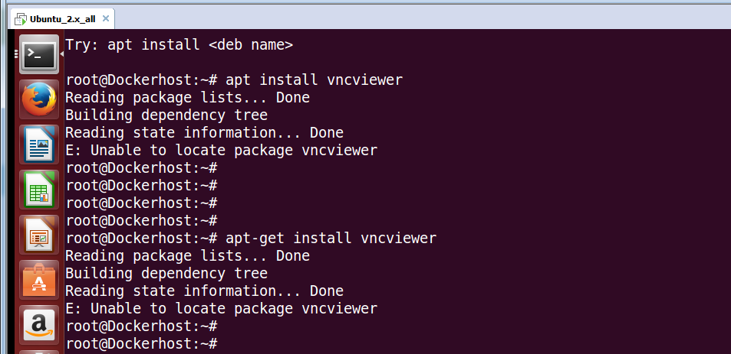

**Install Gift on the ubuntu server :**

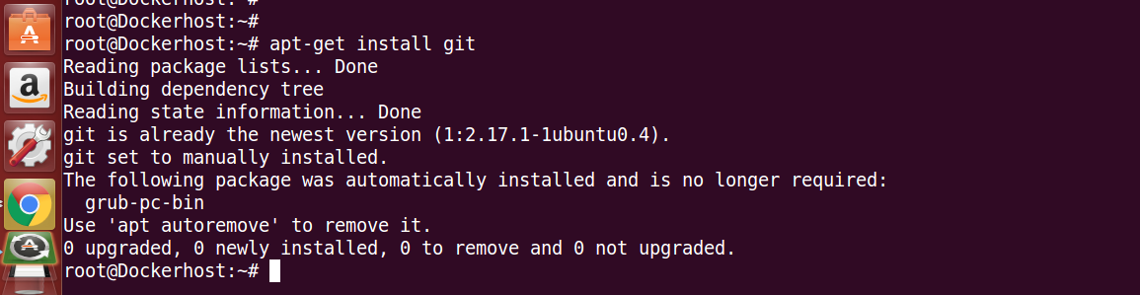

**Logged into Docker Hub and Get Image from DockerHub:**

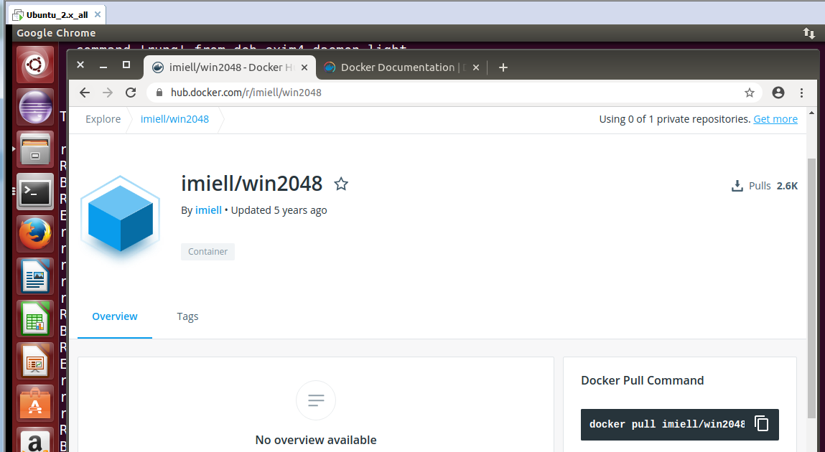

**Pull the image from Docker Hub and check Docker images:**

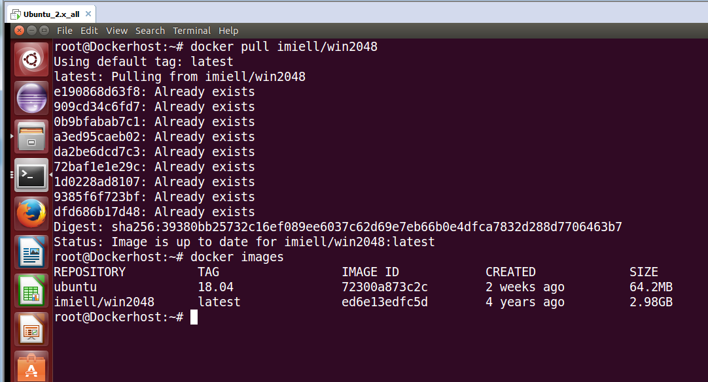

**Run a container as Bash shell:**

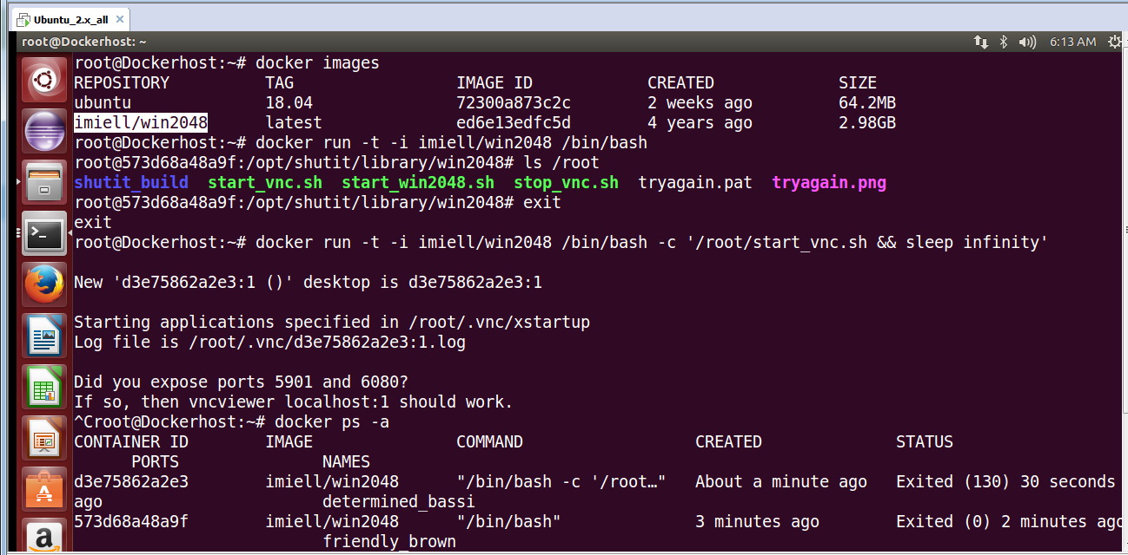

**Remover Docker image with 'rm' command 'ps' to track the containers:**

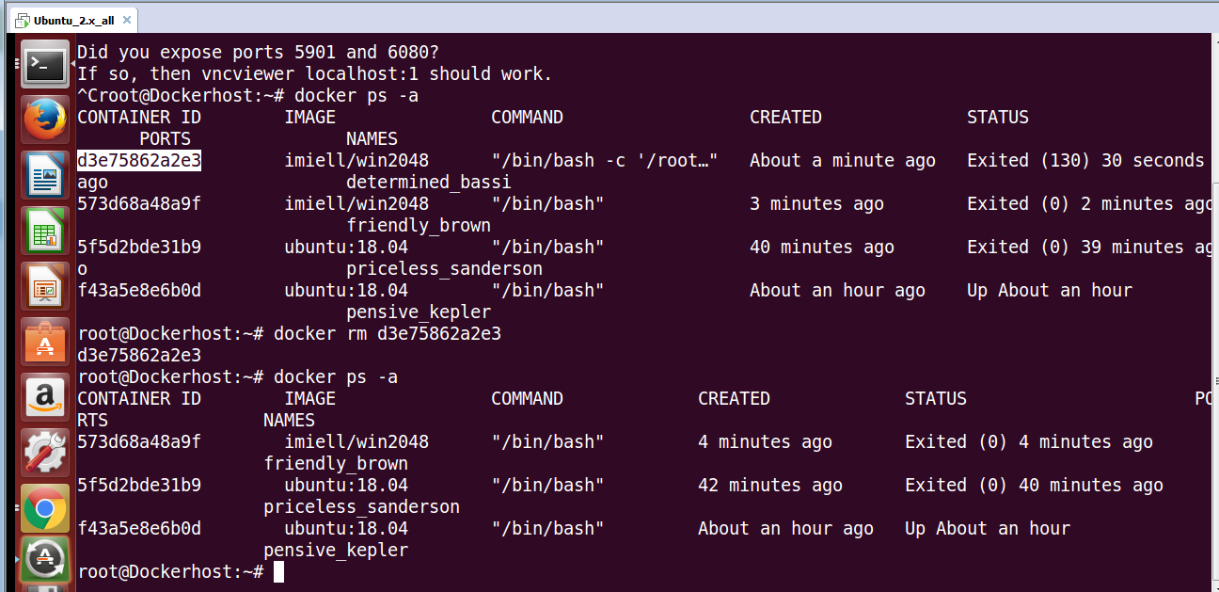

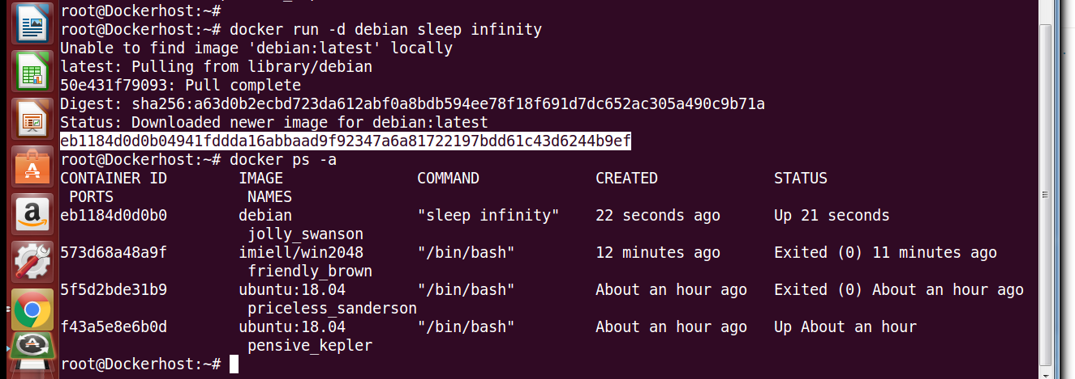

**To See running process of the container 'top' and examine the output 'logs':**

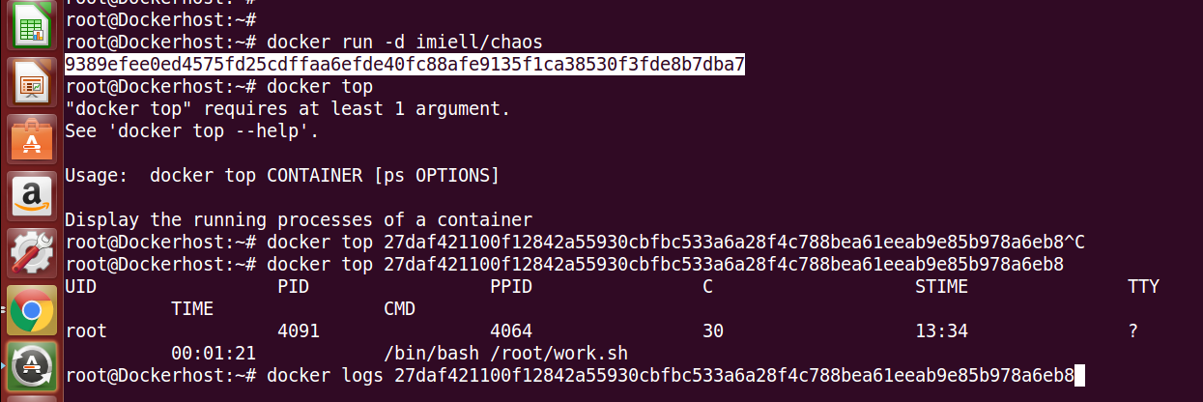

**To complete clean the containers:**

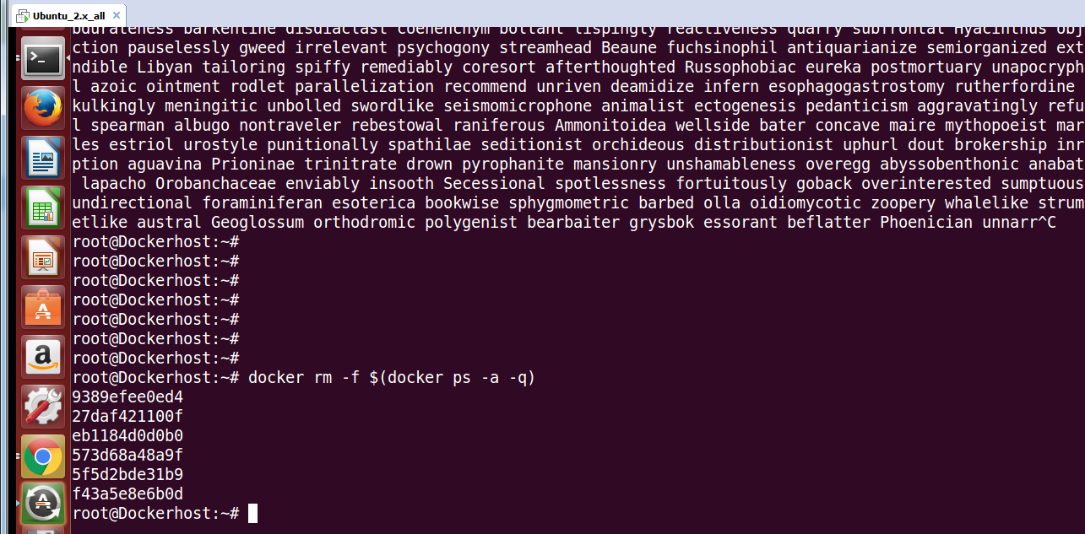

**Log on to Host VM using ssh -X @VMIP:**

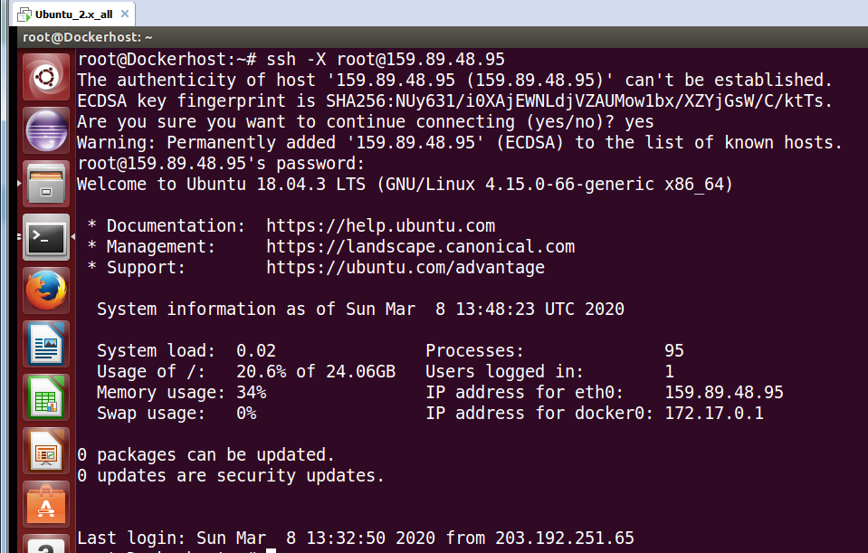

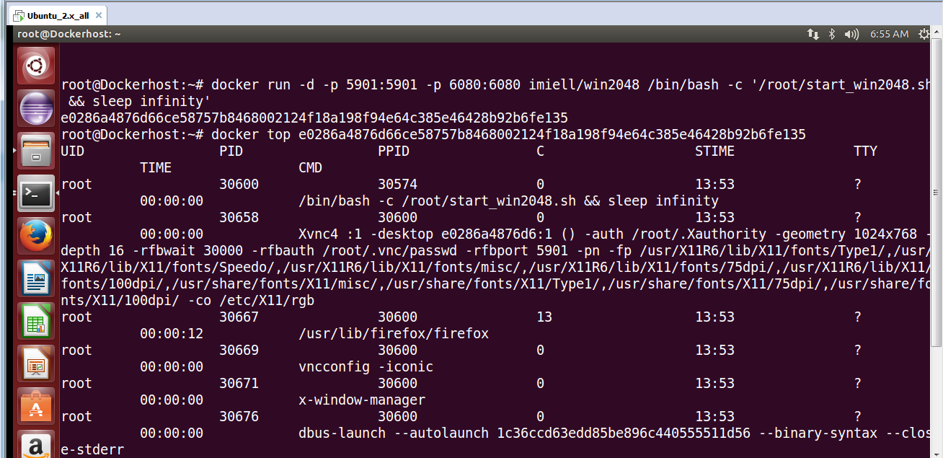

**install xtightvncviewer:**

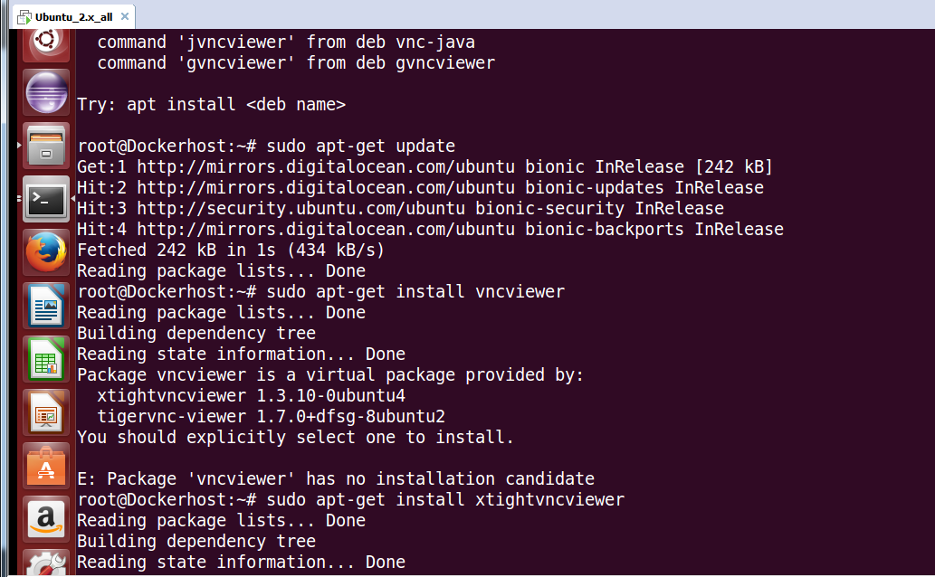

**Run the image on xtightvncviewer:**

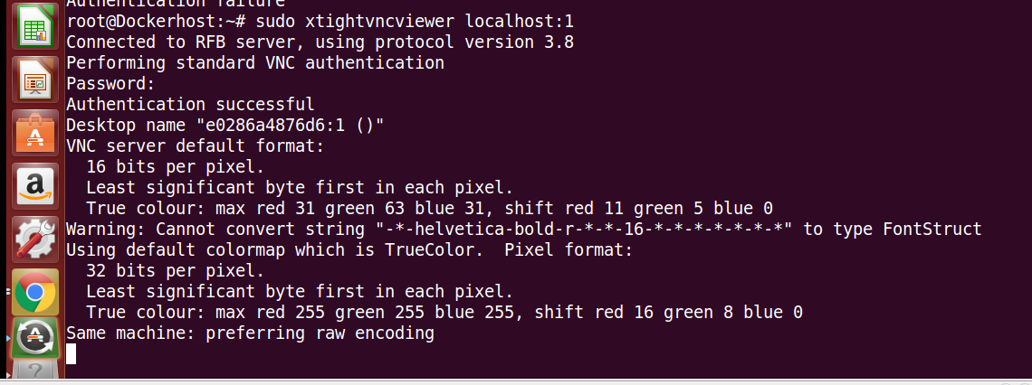

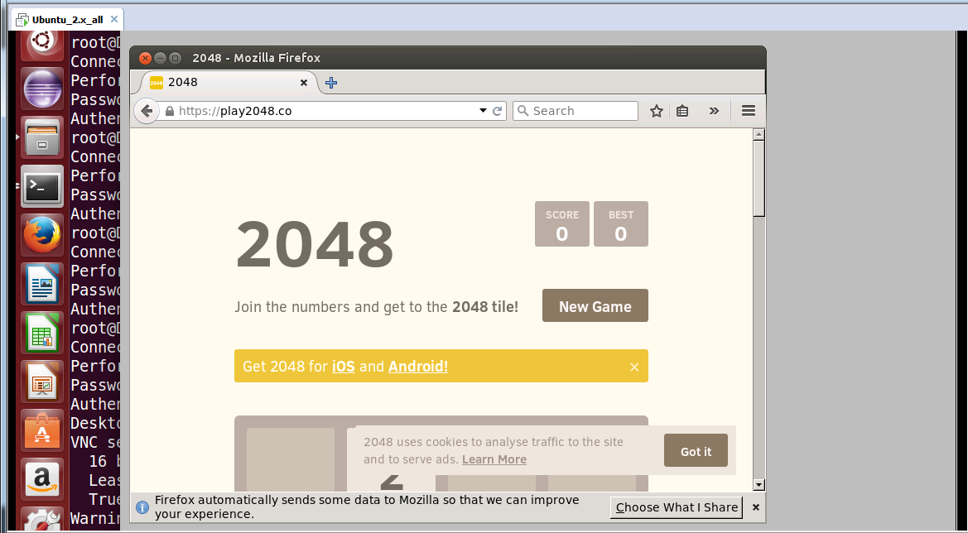

**Save State:**

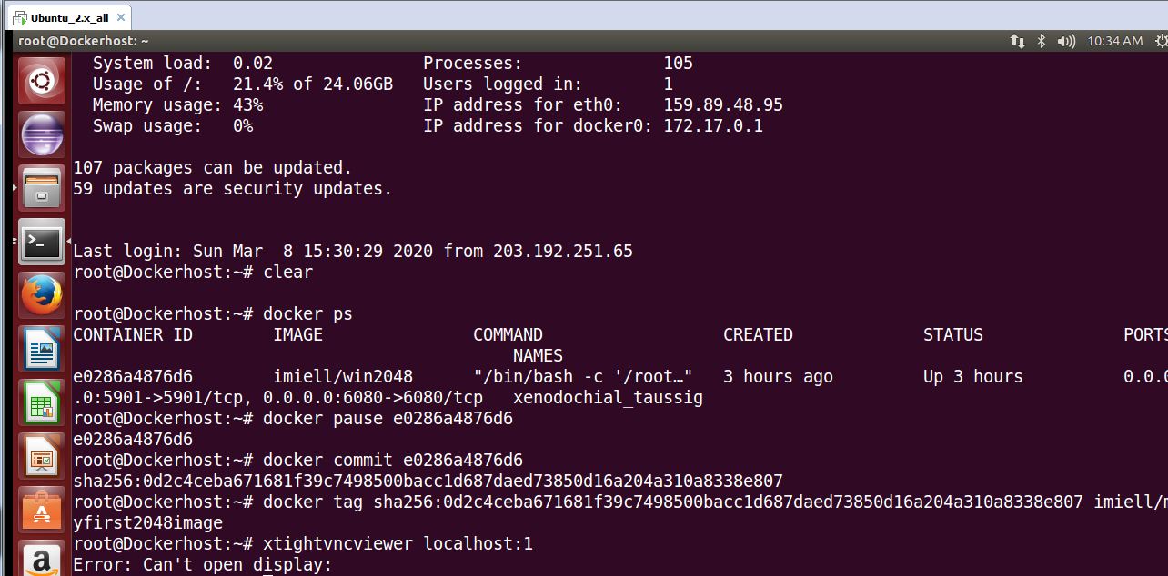

**Upload the image to DockerHub:**

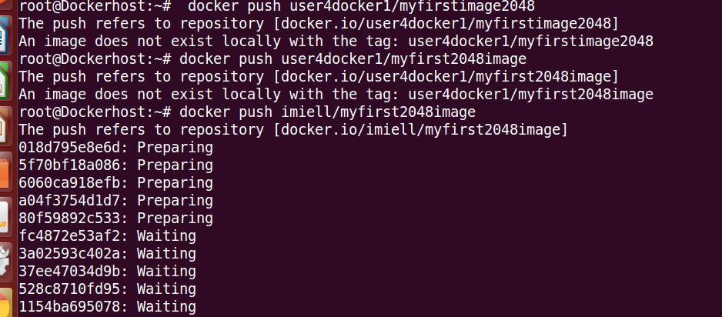

**Docker pull ubuntu and tag with myref and check history and events:**

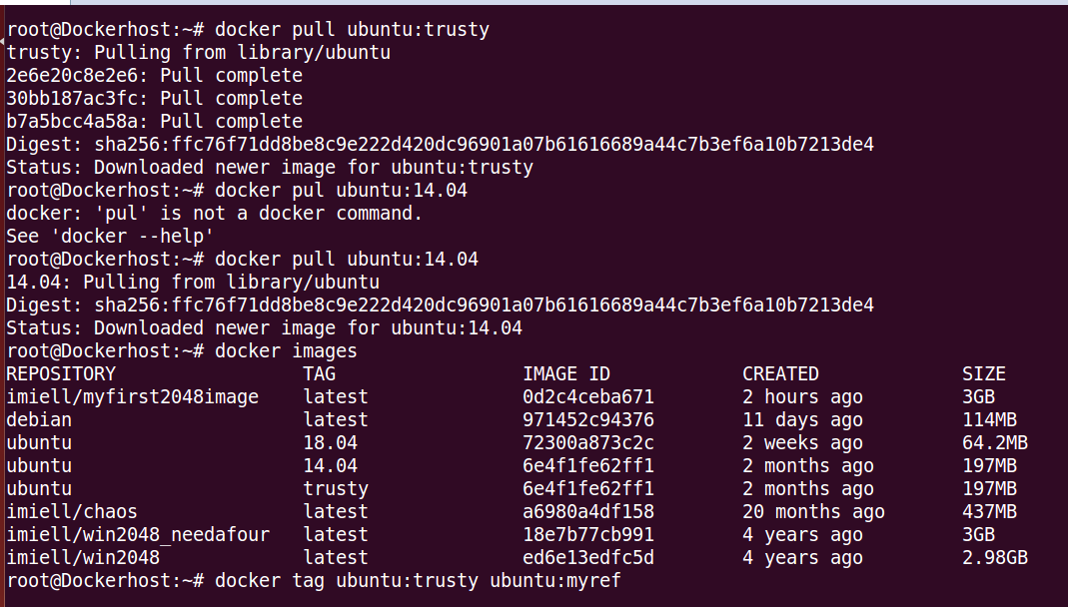

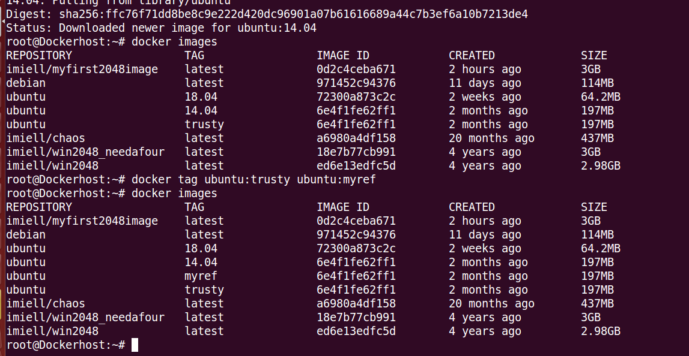

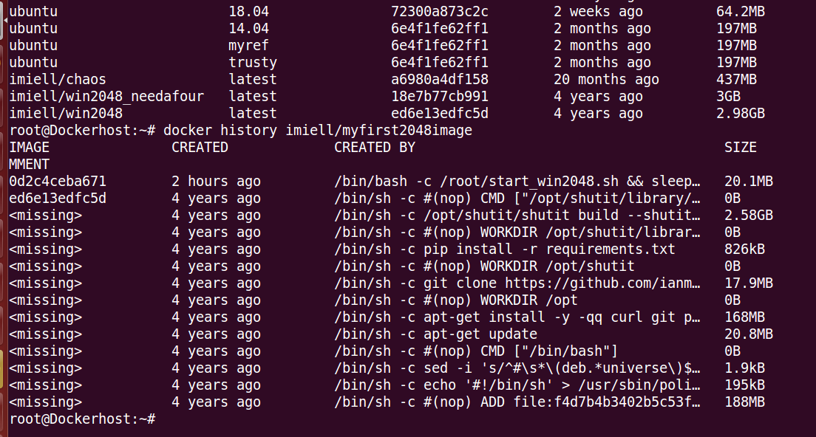

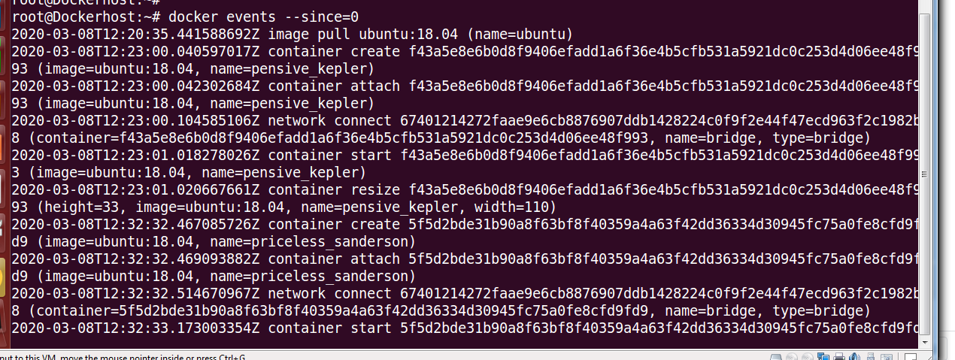

Create a git clone, Built it & verify. Run the themortgagemeter.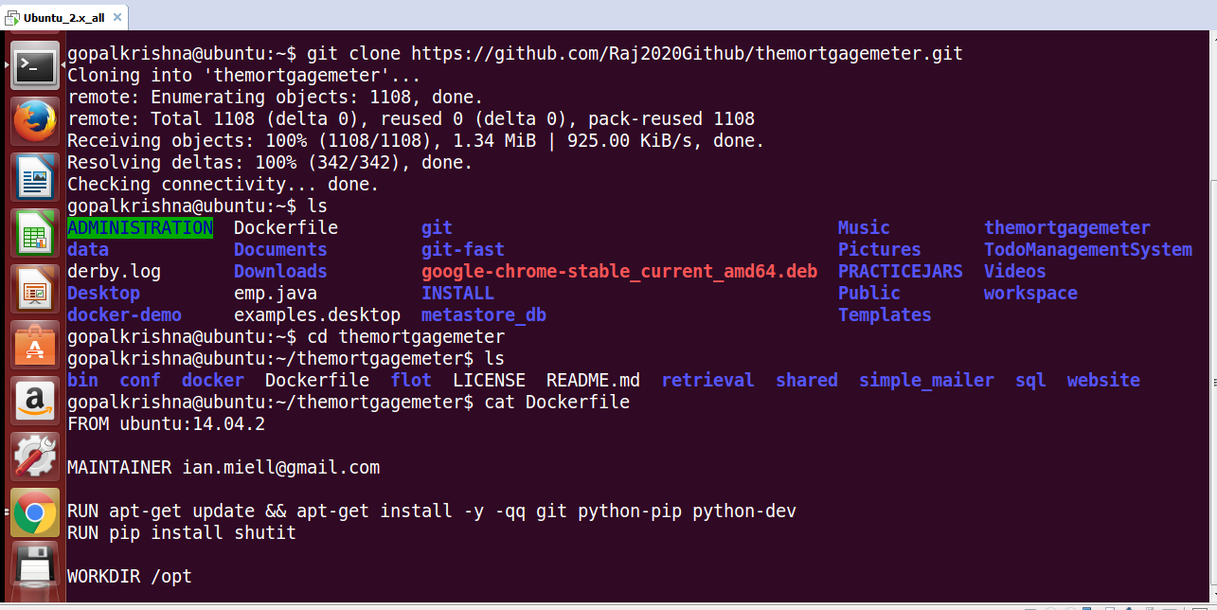

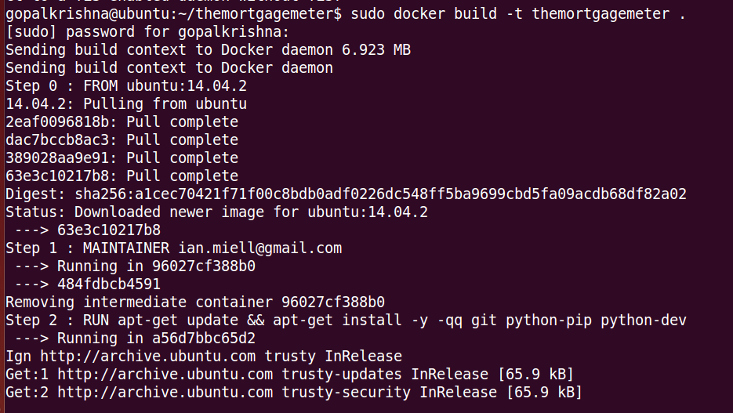

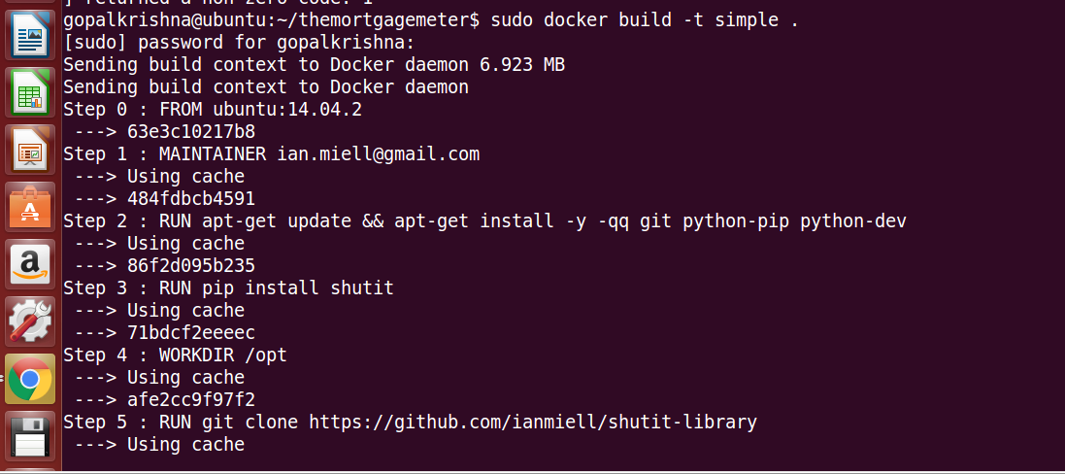

**connect docker host & install python-pip :**

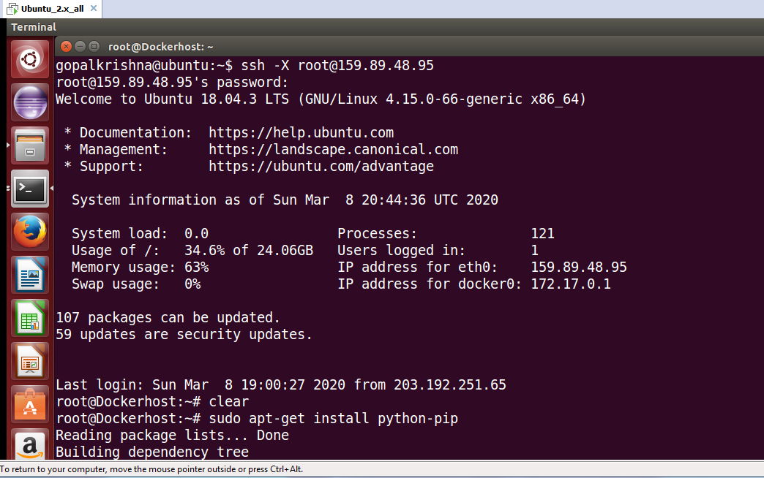

**Install and use Docker compose:**

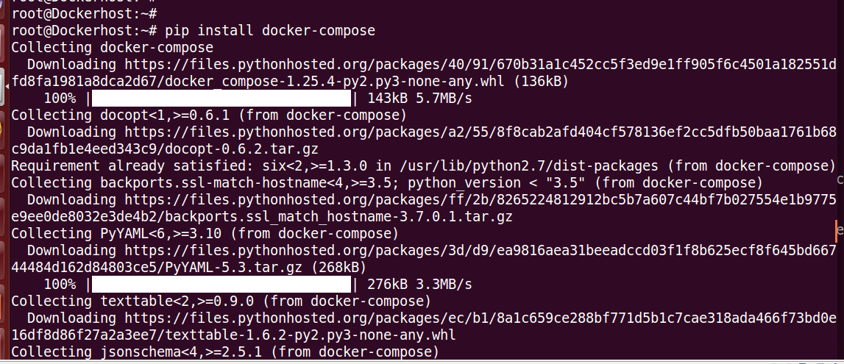

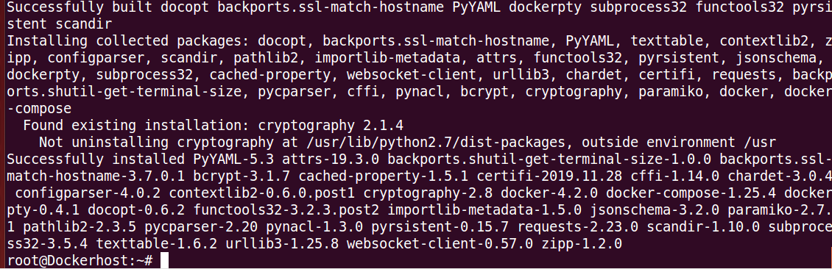

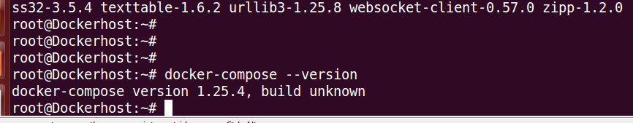

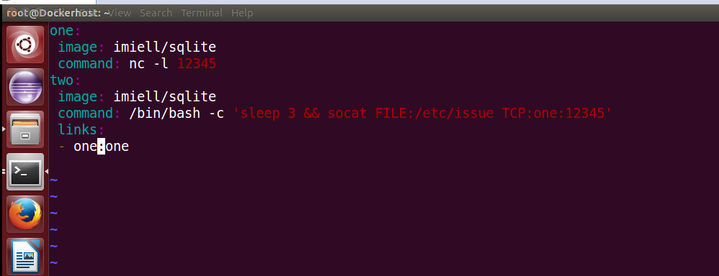

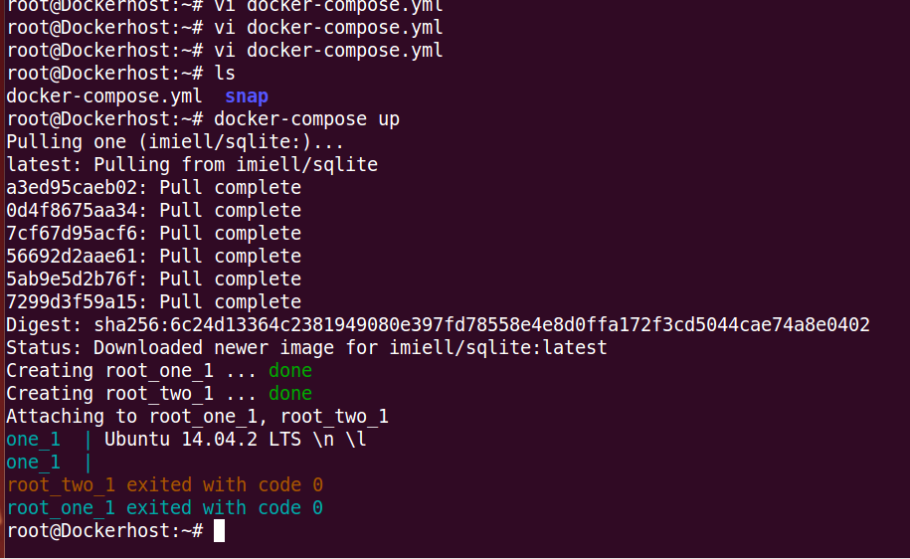

**Configure a container to communicate with a DB on our host:**

